
Year 8 Science 2015

Energy Topic Test

  - Name ____________________________
  - Teacher ____________________________
  - Score _____ / 50 _____ %

 | Cells are the basic building blocks of:  - plants, but not animals.  - animals, but not plants.  - both plants and animals.  - only some parts of plants and animals. | C | 1
 | Which one of the following is not a type of microscope?  - A proton microscope  - A scanning electron microscope  - A light microscope  - A monocular microscope  - A stereo microscope | A | 1
 | If light travels through a lens of magnification ×10 and then through a lens of magnification ×20, the overall magnification will be:  - ×10.  - ×30.  - ×200.  - ×1020. | C | 1
 | The field of view gets smaller when the magnification:  - decreases.  - increases.  - remains the same. | B | 1
 | A drop of pond water is to be viewed using a microscope. It should first be put on:  - the stage.  - a slide.  - a coverslip.  - a lens. | B | 1
 | The control centre of a cell is:  - the nucleus.  - the epicentre.  - the cytoplasm.  - the DNA. | A | 1
 | The green pigment in plant cells is:  - chloroplast.  - chlorophyll.  - lime cordial.  - algae. | B | 1
 | The cell membrane of living cells:  - protects, supports and gives rigid shape to the cell.  - controls the flow of substances in and out of the cell.  - is the part of the cell where photosynthesis takes place.  - supplies energy to all of the other parts of the cell. | B | 1
 | A large vacuole can be found inside the cells of:  - plants.  - animals.  - fungi.  - bacteria. | A | 1
 | Which characteristic do all plants and fungi have in common?  - They are unicellular.  - They make their own food.  - Their cells have cell walls.  - Their cells contain chloroplasts. | C | 1
 | Which of these animal cells have tails that allow them to swim?  - Blood cells  - Trachea cells  - Ova  - Sperm | D | 1
 | Which of the following is one of the biggest differences between plant and animal cells?  - The presence of a cell wall  - The position of the nucleus  - The presence of cytoplasm  - The presence of a cell membrane | A | 1
 | Which plant tissue carries water and dissolved minerals from the soil throughout the plant?  - Xylem  - Phloem  - Cellulose  - Root tissue | A | 1
 | Groups of similar cells that carry out a particular job are called:  - team cells.  - organs.  - organelles.  - tissues. | D | 1
 | Identify parts (a) to (e) on the microscope diagram below.  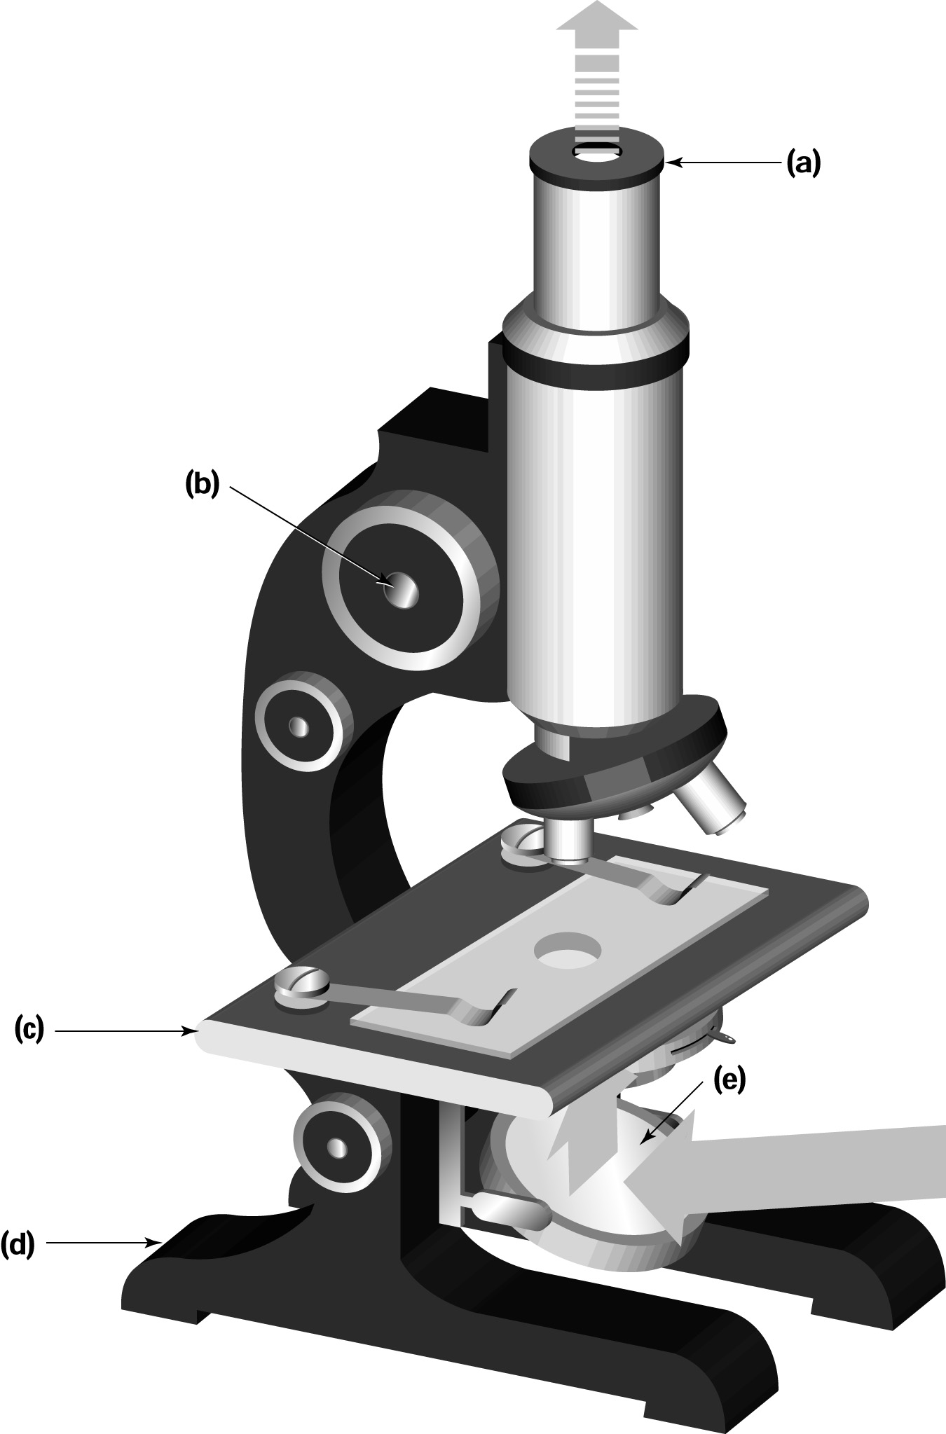 | - Eyepiece lens  - Focus knob  - Stage  - Base  - Mirror/Light source | 5
 | Give two tips for the effective use of a microscope. | Answers will vary but may include:  - Use the microscope on a flat surface.  - Watch from the side when lowering the objective (lower) lens. | 2
 | Rewrite the following sentence to make a true statement:  ‘The human body is made up of a small number of identical cells.’  (Hint: You will need to alter or delete a few words to make it true.) | The human body is made up of lots of different cells. | 2
 | Draw a simple sketch of a human cheek cell. Label the cell membrane and the nucleus. | 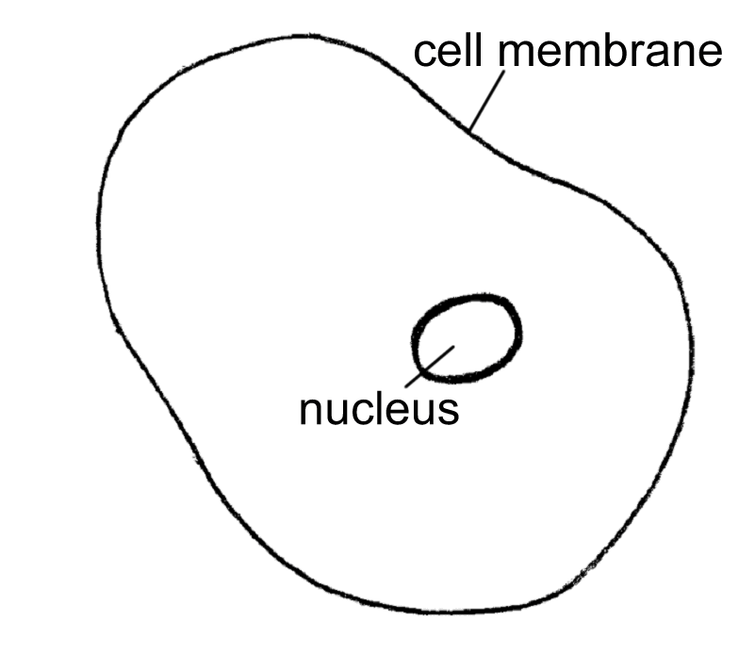 | 3
 | Name three of the kingdoms into which organisms may be grouped. | Kingdoms include:  - Animalia  - Fungi  - Plantae  - Prokaryotae (Monera)  - Protoctista (Protista). | 3
 | What small structures in a cell convert glucose into energy for the cell? | Mitochondria | 1
 | Copy and complete the following sentence:  The large storage cavity in the centre of a plant cell is called a _____. | The large cavity in the centre of a plant cell is called a vacuole. | 1
Organelle Animal cell Plant cell  Nucleus Present Present  Cell wall Absent Present  Cell membrane Present Present  Cytoplasm Present Present  Large vacuole Absent Present  Chloroplast Absent Present  Organelle Animal cell Plant cell  Nucleus  Cell wall  Cell membrane  Cytoplasm  Large vacuole  Chloroplast | Use ticks and crosses to identify which organelles are found in the various cell types. |  | 6
 | Complete the table below to include the names and functions of the cell parts in plant and animal cells.  Name of cell part Function of cell part  Nucleus  Site of chemical reactions  Cell membrane  Site of photosynthesis  Cell wall | Name of cell part Function of cell part  Nucleus Control centre of the cell  Cytoplasm Mitochondria Site of chemical reactions  Cell membrane Controls the substances moving in and out of the cell  Chloroplast Site of photosynthesis  Cell wall Protects and supports the cell | 5
 | List three different types of animal cell. | Examples include: blood, cheek and muscle cells. | 3
 | Describe the differences between plant and animal cells. | Plant cells have a cellulose cell wall and a central vacuole containing cell sap. A plant cell may also contain chloroplasts. | 3
 | Give two ways in which prokaryotes are different from eukaryotes. | Examples include:  - Prokaryotes do not have a membrane around their organelles but eukaryotes do.  - Prokaryotes evolved before eukaryotes.  - Prokaryotes are simpler organisms than eukaryotes.  • Prokaryotes have no nucleus. | 2

